Error Screenshot:
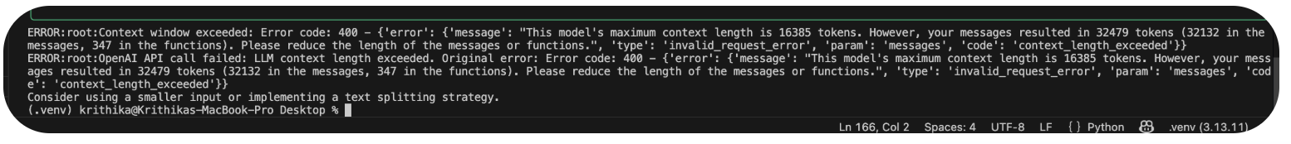
Fix:
Switched the model from 3.5 turbo to gpt 4o .

